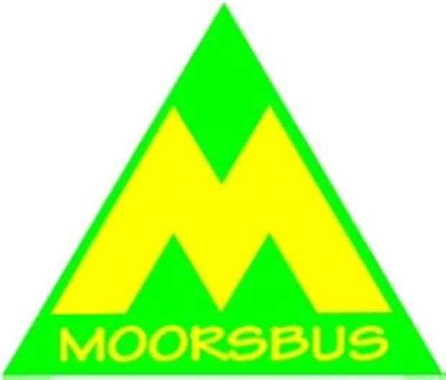 Please join us/renew your annual membership
Friends of Moorsbus is a not-for-profit, unincorporated members organisation. We work alongside Moorsbus Community Interest Company (a smaller volunteer team) to start new services to replace the North York Moors National Park Authority Moorsbus that ended in 2013. We are having a fresh look at the opportunities. We are finding out what people want by asking Members, other passengers, and town and parish councils.
Just by being a member, you are helping to make it happen, by showing that you support us. You can also get more involved if you wish too. We do a newsletter, Members meetings, guided walks and social events. You can also get “MoorRewards” special offers with your Membership card, wherever you see the “MoorRewards” triangle displayed. You’ll find more information at www.moorsbus.org/moorrewards.html.
We have a bus fund if you want to donate to support Moorsbus. Your Membership fees are also used for the Bus Fund, after we have covered printing and postage costs. Please pass this form to a friend if you have already paid your Membership.
North York Moors Moorsbus services have always carried visitors and residents from many different areas. We are creating an affordable transport system to, from and around the Moors. The important factors are convenience, comfort, cost, connections and continuity.
There are environmental reasons, to, for trying to reduce the number of cars on the Moors.
Friends of Moorsbus Membership Application or Renewal Form
(We have over 250 non-internet Members, and over 300 on-line. If you CAN email your information and supply an email address, it saves us time and postage)
Title: Mr/Mrs/Miss/Ms Name:
Address: Telephone:-
Postcode: Date:-
Your Email: Our email friendsofmoorsbus@outlook.com
Any special ways in which you would like to help? ………………………………………………………………
……………………………………………………………………………………………………………………………………………….
(We will never share your details with anyone else, and will only send you Moorsbus info)
Membership Fee £5......... Bus Fund Donation £........ Total £........
Cheques to “Friends of Moorsbus”. Bank transfer; 60-83-01 20339939. Stamps are welcome too! Please enclose a DL size stamped, self addressed envelope – thank you!
Send to;
Friends of Moorsbus, 4 Foundry Cottages, Wrelton, YO18 8PF. Telephone 01751 477216.

